Acc: 0.00045966444

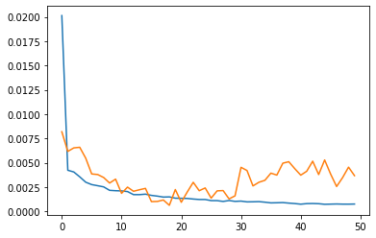

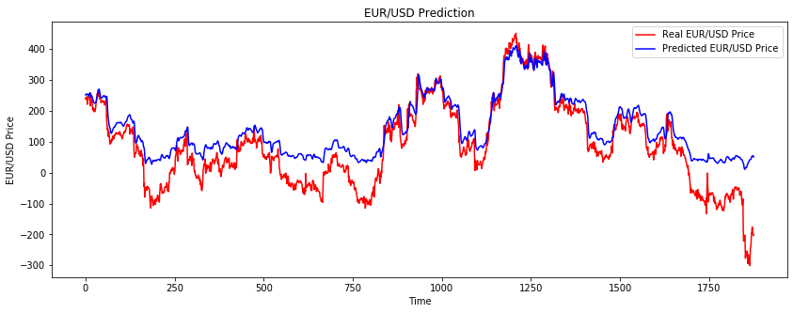

ACC:

0.000287687

Loss

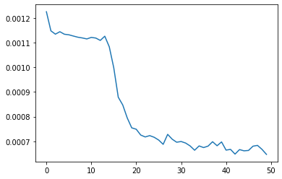

val_loss

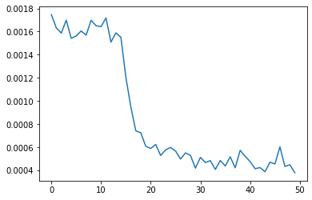

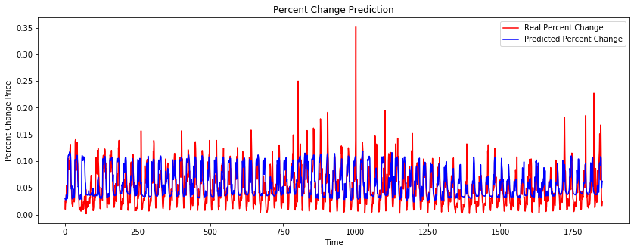

Experiment 3:

Model: "sequential_1"

_________________________________________________________________

Layer (type) Output Shape Param #

=================================================================

lstm_4 (LSTM) (None, 60, 60) 16080

_________________________________________________________________

dropout_4 (Dropout) (None, 60, 60) 0

_________________________________________________________________

lstm_5 (LSTM) (None, 60, 60) 29040

_________________________________________________________________

dropout_5 (Dropout) (None, 60, 60) 0

_________________________________________________________________

lstm_6 (LSTM) (None, 60, 80) 45120

_________________________________________________________________

dropout_6 (Dropout) (None, 60, 80) 0

_________________________________________________________________

lstm_7 (LSTM) (None, 120) 96480

_________________________________________________________________

dropout_7 (Dropout) (None, 120) 0

_________________________________________________________________

dense_1 (Dense) (None, 1) 121

=================================================================

Total params: 186,841

Trainable params: 186,841

Non-trainable params: 0

Loss

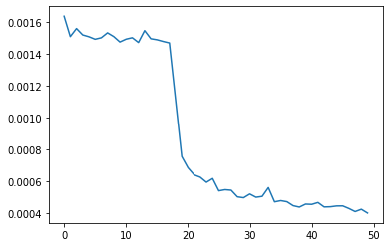

val_loss



Acc: 0.0007215007

MSE: 0.0006179639357529031

Change the Dataset:

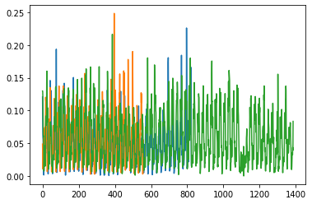

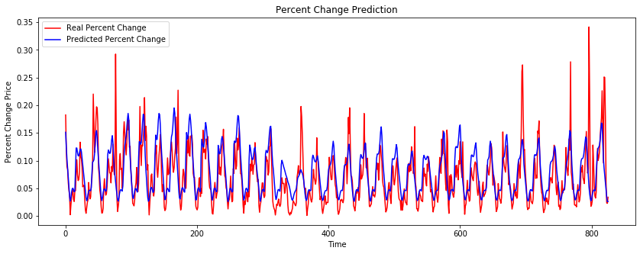

Experiment 4